O’ZBEKISTON RESPUBLIKASI OLIY TA’LIM, FAN VA INNOVATSIYA VAZIRLIGI
ABU RAYXON BERUNIY NOMIDAGI URGANCH DAVLAT UNIVERSITETI

Kompyuter injineringgi fakulteti
„Kompyuter ilmlari va dasturlash texnologiyalari” yo’nalishi 234-guruh
Komilova Farangizning “Web texnologiya ” fanidan
10-laboratoriya mashg’uloti

Qabul qildi: ________________________________________________

Urganch-2025
Labоratоriya ishi №10
Mavzu: CSS transition va animatsiya elementlarini yaratish
Nazariy qism.
Transition CSS-dagi oddiy mulklarning qiymati bir holatdan boshqa holatga (masalan hover, focus, active, class o‘zgarishi) o‘tganda silliq animatsion o‘tishni yaratadi. Qaysi mulk o‘zgarishi animatsiya bo‘lishini belgilaydi. Masalan:width,height,background-color,transform,opacity.

Transitionning cheklovlari:
- Faqat ikki holat orasidagi o‘tishni bajaradi.
- Doim trigger kerak.
- Infinite loop (cheksiz takrorlanish) qila olmaydi.
- Ko‘p bosqichli harakat qila olmaydi.
Animation elementning vaqt ichida qanday o‘zgarishini, qaysi paytda qaysi holatda bo‘lishini to‘liq nazorat qilish imkonini beradi. Bunda @keyframes orqali harakatning turli bosqichlari belgilanadi.

Animation imkoniyatlari:
- Trigger kerak emas (animatsiya avtomatik boshlanadi)
- Cheksiz takrorlash mumkin (infinite)
- Ko‘p bosqichli harakatlarni qilishi mumkin (0–100%)
- Har bir bosqichda o‘zgarish boshqacha bo‘lishi mumkin
- Animatsiyani to‘xtatish, qaytish, orqaga ishlash va hokazo
@keyframes — asosiy qism
Misol:
@keyframes move {
0% { transform: translateX(0); }
50% { transform: translateX(200px); }
100% { transform: translateX(0); }
}

Animation xususiyatlari:

1. animation-name-keyframes nomi.

2. animation-duration-animatsiya qancha vaqt davom etishi.

3. animation-timing-function

Transition va Animation farqi
Xususiyat | Transition | Animation
Trigger kerakmi? | Ha | Yo‘q
Takrorlash | Yo‘q | Ha
Ko‘p bosqichli harakat | Yo‘q (faqat 2 holat) | Ha
@keyframes | Kerak emas | Kerak
Murakkab animatsiyalar | Yo‘q | Ha
To‘xtatish | Qiyin | Oson

Qachon qaysi biridan foydalaniladi?

Transition – oddiy o‘tishlar uchun:
- Hover effektlar
- Tugma bosilganda o‘zgarish
- Menyu ochilishi
- Kartalarning holat o‘zgarishi

Animation – murakkab harakatlar uchun:
- Banner / slider animatsiyalari
- Loding animatsiya
- Splash screen harakatlari
- “Jump”, “Bounce”, “Pulse” effektlar
- Ketma-ket sahna animatsiyalari
Amaliy qism: Anaimatsiya yordamida sayt yaratish
Kod qismi:
<!DOCTYPE html>
<html lang="en">
<head>
<meta charset="UTF-8">
<title>Animatsiya sayti</title>

<!-- Iconlar uchun -->
<link rel="stylesheet" href="https://cdnjs.cloudflare.com/ajax/libs/font-awesome/6.5.0/css/all.min.css">

<style>
body {
margin: 0;
height: 100vh;
overflow: hidden;

/* Orqa fon: chiroyli yulduzli tungi osmon */
background: url('https://suret.pics/uploads/posts/2023-09/1695388407_019.jpg') no-repeat center center fixed;
background-size: cover;

font-family: Arial, sans-serif;
}

/* Orqa fon yaltirash efekti */
body::after {
content: "";
position: absolute;
top: 0; left: 0; right: 0; bottom: 0;
background: radial-gradient(circle, rgba(255,255,255,0.15), transparent 70%);
animation: glow 6s ease-in-out infinite;
pointer-events: none;
}

@keyframes glow {
0%, 100% { opacity: 0.2; }
50% { opacity: 0.5; }
}

@keyframes float {
0% { transform: translateY(0); }
50% { transform: translateY(-25px); }
100% { transform: translateY(0); }
}

@keyframes spin { from { transform: rotate(0deg); } to { transform: rotate(360deg); } }

/* Orbit rasmlar uchun animatsiyalar */
@keyframes orbit1 { 0% { transform: rotate(0deg) translate(250px) rotate(0deg); } 100% { transform: rotate(360deg) translate(250px) rotate(-360deg); } }
@keyframes orbit2 { 0% { transform: rotate(90deg) translate(300px) rotate(0deg); } 100% { transform: rotate(-270deg) translate(300px) rotate(-360deg); } }
@keyframes orbit3 { 0% { transform: rotate(180deg) translate(200px) rotate(0deg); } 100% { transform: rotate(540deg) translate(200px) rotate(-360deg); } }
@keyframes orbit4 { 0% { transform: rotate(270deg) translate(350px) rotate(0deg); } 100% { transform: rotate(-90deg) translate(350px) rotate(-360deg); } }
@keyframes orbit5 { 0% { transform: rotate(45deg) translate(400px) rotate(0deg); } 100% { transform: rotate(405deg) translate(400px) rotate(-360deg); } }

.orbitImg {
position: absolute;
width: 100px;
border-radius: 50%;
top: 50%;
left: 50%;
transform-origin: center center;
box-shadow: 0 0 20px white;
}

.orbit1 { animation: orbit1 12s linear infinite; }
.orbit2 { animation: orbit2 15s linear infinite; }
.orbit3 { animation: orbit3 18s linear infinite; }
.orbit4 { animation: orbit4 20s linear infinite; }
.orbit5 { animation: orbit5 25s linear infinite; }

/* Ikonalar */
.icon {
position: absolute;
font-size: 60px;
color: white;
text-shadow: 0 0 20px white;
animation: float 4s ease-in-out infinite;
}

/* Ikonalar ekran bo'ylab turli joylarda va kattalashtirilgan */
.star { top: 10%; left: 15%; color: #fff000; font-size: 90px; } /* kattalashdi */
.heart { top: 12%; left: 50%; color: #ff004c; animation-duration: 3s; font-size: 90px; }
.bolt { top: 8%; left: 75%; color: #00ff00; animation-duration: 2.5s; font-size: 90px; }

.infinity { bottom: 10%; left: 20%; color: #00bfff; font-size: 120px; } /* kattalashdi */
.moon { bottom: 12%; left: 50%; color: #d6d6ff; font-size: 110px; }
.sun { bottom: 8%; left: 75%; color: #d4ff00; font-size: 130px; animation: spin 10s linear infinite; }

</style>
</head>
<body>

<!-- 5 ta ekran atrofida aylanadigan rasm -->
<img src="https://encrypted-tbn0.gstatic.com/images?q=tbn:ANd9GcR3nbud_cFJsbtJdVqgZErnhyPFld5T_nJW2w&s" class="orbitImg orbit1">
<img src="https://encrypted-tbn0.gstatic.com/images?q=tbn:ANd9GcR3nbud_cFJsbtJdVqgZErnhyPFld5T_nJW2w&s" class="orbitImg orbit2">
<img src="https://encrypted-tbn0.gstatic.com/images?q=tbn:ANd9GcR3nbud_cFJsbtJdVqgZErnhyPFld5T_nJW2w&s" class="orbitImg orbit3">
<img src="https://encrypted-tbn0.gstatic.com/images?q=tbn:ANd9GcR3nbud_cFJsbtJdVqgZErnhyPFld5T_nJW2w&s" class="orbitImg orbit4">
<img src="https://encrypted-tbn0.gstatic.com/images?q=tbn:ANd9GcR3nbud_cFJsbtJdVqgZErnhyPFld5T_nJW2w&s" class="orbitImg orbit5">

<!-- Ikonkalar -->
<i class="fa-solid fa-star icon star"></i>
<i class="fa-solid fa-heart icon heart"></i>
<i class="fa-solid fa-bolt icon bolt"></i>
<i class="fa-solid fa-infinity icon infinity"></i>
<i class="fa-regular fa-moon icon moon"></i>
<i class="fa-solid fa-sun icon sun"></i>

</body>
</html>

Kod natijasi:
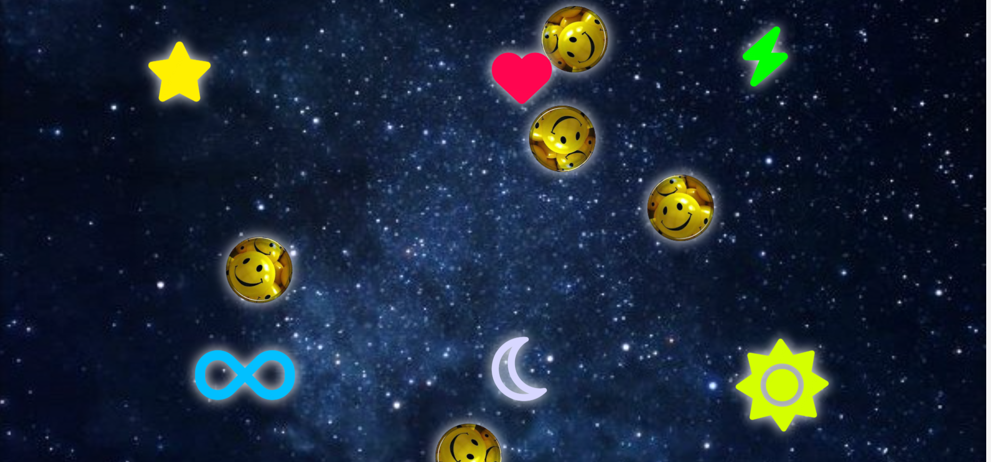
Xulosa
CSS da elementlarning ko‘rinishi va holatini silliq o‘zgartirish uchun transition va animation konseptlari ishlatiladi. Bu ikki vosita saytlarni statikdan interaktiv va jonli holatga olib keladi, lekin ularning ishlash tamoyillari va qo‘llanilishi turlicha.Transition – elementning bir holatdan boshqasiga o‘tishini foydalanuvchi hodisasi (hover, focus, click) orqali silliq tarzda amalga oshiradi. Bu oddiy va tez ishlatiladigan usul bo‘lib, faqat bir martalik yoki hodisaga bog‘langan o‘zgarishlarni boshqaradi.Animation – elementni ko‘p bosqichli, takroriy yoki murakkab harakatlar bilan jonlantirish imkonini beradi.

